HTML

1

What is html?

HTML is the standard markup language for creating Web pages.

* HTML stands for Hyper Text Markup Language
* HTML describes the structure of Web pages using markup
* HTML elements are the building blocks of HTML pages
* HTML elements are represented by tags
* HTML tags label pieces of content such as "heading", "paragraph", "table", and so on
* Browsers do not display the HTML tags, but use them to render the content of the page

Example :-

<html>  
<head>  
<title>Page Title</title>  
</head>  
<body>  
<h1>My First Heading</h1>  
<p>My first paragraph.</p>  
  
</body>  
</html>

### Example Explained

* The <html> element is the root element of an HTML page
* The <head> element contains meta information about the document
* The <title> element specifies a title for the document
* The <body> element contains the visible page content
* The <h1> element defines a large heading
* The <p> element defines a paragraph

## HTML Tags

HTML tags are element names surrounded by angle brackets:

* <tagname>content goes here...</tagname>
* HTML tags normally come **in pairs** like <p> and </p>
* The first tag in a pair is the **start tag,** the second tag is the **end tag**
* The end tag is written like the start tag, but with a **forward slash** inserted before the tag name.

## Web Browsers

The purpose of a web browser (Chrome, IE, Firefox, Safari) is to read HTML documents and display them.

The browser does not display the HTML tags, but uses them to determine how to display the document:

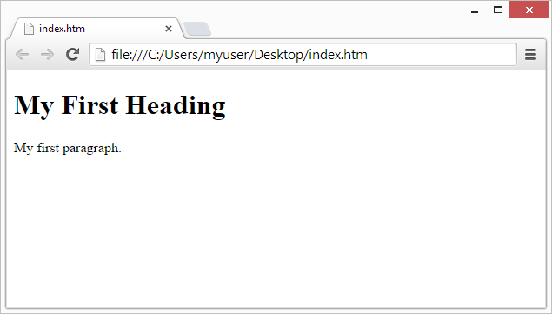

HTML Page Structure

Below is a visualization of an HTML page structure:

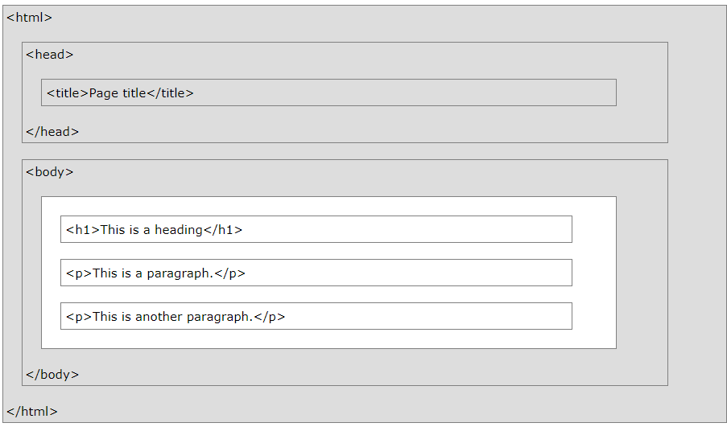

**HTML Versions**

Since the early days of the web, there have been many versions of HTML:

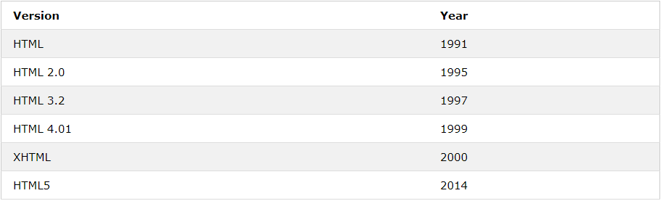

# HTML Headings

Headings are defined with the <h1> to <h6> tags.<h1> defines the most important heading. <h6> defines the least important heading.

## <html>

## <body>

## <h1>Heading 1</h1>

## <h2>Heading 2</h2>

## <h3>Heading 3</h3>

## <h4>Heading 4</h4>

## <h5>Heading 5</h5>

## <h6>Heading 6</h6>

## </body>

## </html>

## Output

# Heading 1

## Heading 2

### Heading 3

#### Heading 4

##### **Heading 5**

###### **Heading 6**

## Headings Are Important:- Search engines use the headings to index the structure and content of your web pages.Users skim your pages by its headings. It is important to use headings to show the document structure.

<h1> headings should be used for main headings, followed by <h2> headings, then the less important <h3>, and so on.

# HTML Images

Images can improve the design and the appearance of a web page.

## HTML Images Syntax

In HTML, images are defined with the <img> tag.

The <img> tag is empty, it contains attributes only, and does not have a closing tag.

The src attribute specifies the URL (web address) of the image:

<img src="*url*">

<html>

<body>

<h2>HTML Image</h2>

<img src="pic\_trulli.jpg" alt="Trulli" width="500" height="333">

</body>

</html>

## The alt Attribute

The alt attribute provides an alternate text for an image, if the user for some reason cannot view it (because of slow connection, an error in the src attribute, or if the user uses a screen reader).

The value of the alt attribute should describe the image:

<img src="img\_chania.jpg" alt="Flowers in Chania">

<html>

<body>

<h2>Alternative text</h2>

<p>The alt attribute should reflect the image content, so users who cannot see the image gets an understanding of what the image contains:</p>

<img src="img\_chania.jpg" alt="Flowers in Chania" width="460" height="345">

</body>

</html>

# HTML Tables

# An HTML table is defined with the <table> tag.Each table row is defined with the <tr> tag. A table header is defined with the <th> tag. By default, table headings are bold and centered. A table data/cell is defined with the <td> tag.

**Example**

<table style="width:100%">  
  <tr>  
    <th>Firstname</th>  
    <th>Lastname</th>   
    <th>Age</th>  
  </tr>  
  <tr>  
    <td>Jill</td>  
    <td>Smith</td>   
    <td>50</td>  
  </tr>  
  <tr>  
    <td>Eve</td>  
    <td>Jackson</td>   
    <td>94</td>  
  </tr>  
</table>

|  |  |  |
| --- | --- | --- |
| HTML Lists An unordered list starts with the <ul> tag. Each list item starts with the <li> tag.The list items will be marked with bullets (small black circles) by default:  <html>  <body>  <h2>An unordered HTML list</h2>  <ul>  <li>Coffee</li>  <li>Tea</li>  <li>Milk</li>  </ul>  </body>  </html> Ordered HTML List An ordered list starts with the <ol> tag. Each list item starts with the <li> tag.  The list items will be marked with numbers by default:  <html>  <body>  <h2>An ordered HTML list</h2>  <ol>  <li>Coffee</li>  <li>Tea</li>  <li>Milk</li>  </ol>  </body>  </html> HTML Links Links are found in nearly all web pages. Links allow users to click their way from page to page. HTML Links - Syntax In HTML, links are defined with the <a> tag:  <a href="*url*">*link text*</a>  Example  <html>  <body>  <h2>HTML Links</h2>  <p><a href="https://www.w3schools.com/html/">Visit our HTML tutorial</a></p>  </body>  </html> HTML Text Formatting HTML uses elements like <b> and <i> for formatting output, like **bold** or *italic* text.  <html><body>  <p><b>This text is bold</b></p>  <p><i>This text is italic</i></p>  </body></html> HTML Forms The HTML <form> element defines a form that is used to collect user input:  <html>  <body>  <h2>Text Input</h2>  <form>  First name:<br>  <input type="text" name="firstname">  <br>  Last name:<br>  <input type="text" name="lastname">  </form>  </body>  </html>  Output  **Text Input**  Top of Form  First name:   Last name: HTML IframesAn iframe is used to display a web page within a web page. **Iframe Syntax**  An HTML iframe is defined with the <iframe> tag:  <iframe src="URL"></iframe>  **Iframe - Set Height and Width**  Use the height and width attributes to specify the size of the iframe.  <iframe src="demo\_iframe.htm" height="200" width="300"></iframe>  **Example** <!DOCTYPE html><html><body><h2>HTML Iframes</h2><p>You can use the height and width attributes to specify the size of the iframe:</p><iframe src="demo\_iframe.htm" height="200" width="300"></iframe></body></html>HTML Comments Comment tags are used to insert comments in the HTML source code.  <!-- Write your comments here -->  **Example**  <!DOCTYPE html>  <html>  <body>  <!-- This is a comment -->  <p>This is a paragraph.</p>  <!-- Comments are not displayed in the browser -->  </body>  </html> HTML LinksLinks are found in nearly all web pages. Links allow users to click their way from page to page. **HTML Links - Hyperlinks**  HTML links are hyperlinks.  You can click on a link and jump to another document.  When you move the mouse over a link, the mouse arrow will turn into a little hand.  HTML Links - Syntax  In HTML, links are defined with the <a> tag:  <a href="*url*">*link text*</a>  **Example**  <!DOCTYPE html>  <html>  <body>  <h2>HTML Links</h2>  <p><a href="https://www.w3schools.com/html/">Visit our HTML tutorial</a></p>  </body>  </html> Bottom of Form CSS |  |  |

# HTML Styles – CSS

CSS describes how HTML elements are to be displayed on screen, paper, or in other media.

CSS **saves a lot of work**. It can control the layout of multiple web pages all at once.

CSS can be added to HTML elements in 3 ways:

* **Inline** - by using the style attribute in HTML elements
* **Internal** - by using a <style> element in the <head> section
* **External** - by using an external CSS file

## Inline CSS

An inline CSS is used to apply a unique style to a single HTML element.

An inline CSS uses the style attribute of an HTML element.

This example sets the text color of the <h1> element to blue:

Example

<h1 style="color:blue;">This is a Blue Heading</h1>

## Internal CSS

An internal CSS is used to define a style for a single HTML page.

An internal CSS is defined in the <head> section of an HTML page, within a <style> element:

<html>  
<head>  
<style>  
body {background-color: powderblue;}  
h1   {color: blue;}  
p    {color: red;}  
</style>  
</head>  
<body>  
  
<h1>This is a heading</h1>  
<p>This is a paragraph.</p>  
  
</body>  
</html>

## External CSS

An external style sheet is used to define the style for many HTML pages.

**With an external style sheet, you can change the look of an entire web site, by changing one file!**

To use an external style sheet, add a link to it in the <head> section of the HTML page:

<html>  
<head>  
  <link rel="stylesheet" href="styles.css">  
</head>  
<body>  
  
<h1>This is a heading</h1>  
<p>This is a paragraph.</p>  
  
</body>  
</html>

An external style sheet can be written in any text editor. The file must not contain any HTML code, and must be saved with a .css extension.

Here is how the "styles.css" looks:

body {  
    background-color: powderblue;  
}  
h1 {  
    color: blue;  
}  
p {  
    color: red;  
}

# The id Attribute

The id attribute specifies a unique id for an HTML element (the value must be unique within the HTML document).

The id value can be used by CSS and JavaScript to perform certain tasks for a unique element with the specified id value.

In CSS, to select an element with a specific id, write a hash (#) character, followed by the id of the element:

<html>

<head>

<style>

#myHeader {

background-color: lightblue;

color: black;

padding: 40px;

text-align: center;

}

</style>

</head>

<body>

<h2>The id Attribute</h2>

<p>Use CSS to style an element with the id "myHeader":</p>

<h1 id="myHeader">My Header</h1>

</body>

</html>

CSS Margins

The CSS margin properties are used to create space around elements, outside of any defined borders.

With CSS, you have full control over the margins. There are properties for setting the margin for each side of an element (top, right, bottom, and left).

Margin - Individual Sides

CSS has properties for specifying the margin for each side of an element:

* margin-top
* margin-right
* margin-bottom
* margin-left

All the margin properties can have the following values:

* auto - the browser calculates the margin
* *length* - specifies a margin in px, pt, cm, etc.
* *%* - specifies a margin in % of the width of the containing element
* inherit - specifies that the margin should be inherited from the parent element

example-

<!DOCTYPE html>

<html>

<head>

<style>

div {

border: 1px solid black;

margin-top: 100px;

margin-bottom: 100px;

margin-right: 150px;

margin-left: 80px;

background-color: lightblue;

}

</style>

</head>

<body>

<h2>Using individual margin properties</h2>

<div>This div element has a top margin of 100px, a right margin of 150px, a bottom margin of 100px, and a left margin of 80px.</div>

</body>

</html>

Background Color

The background-color property specifies the background color of an element.

The background color of a page is set like this:

<!DOCTYPE html>

<html>

<head>

<style>

body {

background-color: lightblue;

}

</style>

</head>

<body>

<h1>Hello World!</h1>

<p>This page has a light blue background color!</p>

</body>

</html>

The float Property

The float property is used for positioning and layout on web pages.

The float property can have one of the following values:

* left - The element floats to the left of its container
* right- The element floats to the right of its container
* none - The element does not float (will be displayed just where it occurs in the text). This is default
* inherit - The element inherits the float value of its parent

In its simplest use, the float property can be used to wrap text around images.

Example - float: right;

Center Align Elements

To horizontally center a block element (like <div>), use margin: auto;

Setting the width of the element will prevent it from stretching out to the edges of its container.

The element will then take up the specified width, and the remaining space will be split equally between the two margins:

<!DOCTYPE html>

<html>

<head>

<style>

.center {

margin: auto;

width: 60%;

border: 3px solid #73AD21;

padding: 10px;

}

</style>

</head>

<body>

<h2>Center Align Elements</h2>

<p>To horizontally center a block element (like div), use margin: auto;</p>

<div class="center">

<p><b>Note: </b>Using margin:auto will not work in IE8, unless a !DOCTYPE is declared.</p>

</div>

</body>

</html>

**JAVASCRIPT**

JavaScript is used in millions of Web pages to add functionality, validate forms, detect browsers, and much more

**What is JavaScript?**

* JavaScript was designed to add interactivity to HTML pages
* JavaScript is a scripting language
* A scripting language is a lightweight programming language
* JavaScript is usually embedded directly into HTML pages
* JavaScript is an interpreted language (means that scripts execute without preliminary compilation)
* Everyone can use JavaScript without purchasing a license

**What can a JavaScript Do?**

* **JavaScript gives HTML designers a programming tool –**

HTML authors are normally not programmers, but JavaScript is a scripting language with a very simple syntax! Almost anyone can put small “snippets” of code into their HTML pages

* **JavaScript can put dynamic text into an HTML page –**

A JavaScript statement like this: document.write(“<h1>” + name + “</h1>”) can write a variable text into an HTML page

JavaScript is used in millions of Web pages to add functionality, validate forms, detect browsers, and much more

**What is JavaScript?**

* JavaScript was designed to add interactivity to HTML pages
* JavaScript is a scripting language
* A scripting language is a lightweight programming language
* JavaScript is usually embedded directly into HTML pages
* JavaScript is an interpreted language (means that scripts execute without preliminary compilation)
* Everyone can use JavaScript without purchasing a license

**What can a JavaScript Do?**

* **JavaScript gives HTML designers a programming tool –**

HTML authors are normally not programmers, but JavaScript is a scripting language with a very simple syntax! Almost anyone can put small “snippets” of code into their HTML pages

* **JavaScript can put dynamic text into an HTML page –**

A JavaScript statement like this: document.write(“<h1>” + name + “</h1>”) can write a variable text into an HTML page

|  |
| --- |
| <html>  <head>  </head>  <body>  <script type=”text/javascript”>  ….  </script>  </body> |

**Scripts in both the body and the head section:** You can place an unlimited number of scripts in your document, so you can have scripts in both the body and the head section.

|  |
| --- |
| <html>  <head>  <script type=”text/javascript”>  ….  </script>  </head>  <body>  <script type=”text/javascript”>  ….  </script>  </body> |

**Using an External JavaScript**

Sometimes you might want to run the same JavaScript on several pages, without having to write the same script on every page.

To simplify this, you can write a JavaScript in an external file. Save the external JavaScript file with a .js file extension.

**Note:** The external script cannot contain the <script> tag!

To use the external script, point to the .js file in the “src” attribute of the <script> tag:

|  |
| --- |
| <html>  <head>  <script src=”xxx.js”></script>  </head>  <body>  </body>  </html> |

**JavaScript Statements**

JavaScript is a sequence of statements to be executed by the browser.

**JavaScript is Case Sensitive**

Unlike HTML, JavaScript is case sensitive – therefore watch your capitalization closely when you write JavaScript statements, create or call variables, objects and functions.

# JavaScript Operators

**JavaScript Arithmetic Operators**

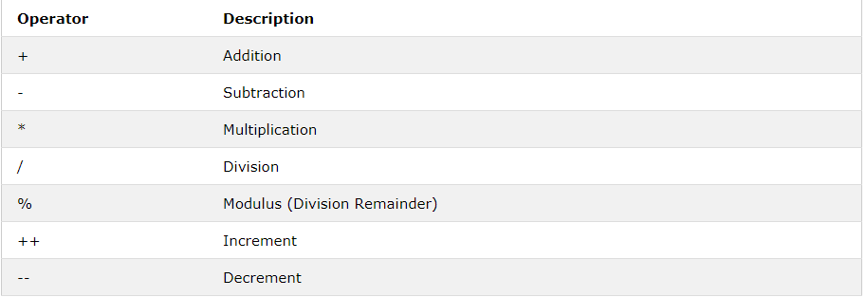

**JavaScript Comparison Operators**

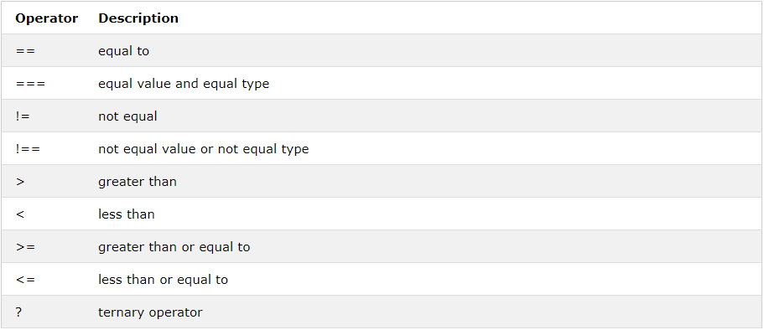

**JavaScript Logical Operators**

**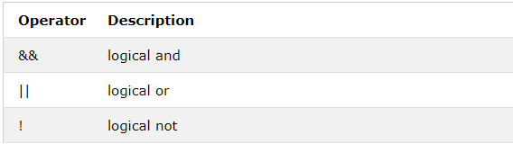**

**JavaScript Bitwise Operators**

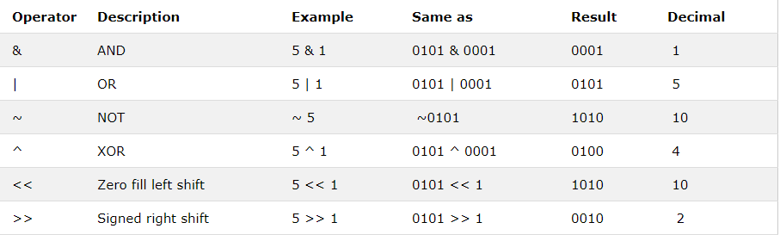

Example

<!DOCTYPE html>

<html>

<body>

<h2>JavaScript Operators</h2>

<p>x = 5, y = 2, calculate z = x + y, and display z:</p>

<p id="demo"></p>

<script>

var x = 5;

var y = 2;

var z = x + y;

document.getElementById("demo").innerHTML = z;

</script>

</body>

</html>

\

**BOOTSTRAP**

## Overview

Components and options for laying out your Bootstrap project, including wrapping containers, a powerful grid system, a flexible media object, and responsive utility classes.

**Containers**

Containers are the most basic layout element in Bootstrap and are ****required when using our default grid system****. Choose from a responsive, fixed-width container (meaning its max-widthchanges at each breakpoint) or fluid-width (meaning it’s 100% wide all the time).

While containers can be nested, most layouts do not require a nested container.

<div class="container">

<!-- Content here --></div>

<div class="container-fluid">

...</div>

Use .container-fluid for a full width container, spanning the entire width of the viewport.

Responsive breakpoints

Since Bootstrap is developed to be mobile first, we use a handful of [media queries](https://developer.mozilla.org/en-US/docs/Web/CSS/Media_Queries/Using_media_queries) to create sensible breakpoints for our layouts and interfaces. These breakpoints are mostly based on minimum viewport widths and allow us to scale up elements as the viewport changes.

Bootstrap primarily uses the following media query ranges—or breakpoints—in our source Sass files for our layout, grid system, and components.

// Extra small devices (portrait phones, less than 576px)// No media query since this is the default in Bootstrap

// Small devices (landscape phones, 576px and up)@media (min-width: 576px) { ... }

// Medium devices (tablets, 768px and up)@media (min-width: 768px) { ... }

// Large devices (desktops, 992px and up)@media (min-width: 992px) { ... }

// Extra large devices (large desktops, 1200px and up)@media (min-width: 1200px) { ... }

@include media-breakpoint-up(xs) { ... }@include media-breakpoint-up(sm) { ... }@include media-breakpoint-up(md) { ... }@include media-breakpoint-up(lg) { ... }@include media-breakpoint-up(xl) { ... }

// Example usage:@include media-breakpoint-up(sm) {

.some-class {

display: block;

}}

We occasionally use media queries that go in the other direction (the given screen size or smaller.

// Extra small devices (portrait phones, less than 576px)@media (max-width: 575.98px) { ... }

// Small devices (landscape phones, less than 768px)@media (max-width: 767.98px) { ... }

// Medium devices (tablets, less than 992px)@media (max-width: 991.98px) { ... }

// Large devices (desktops, less than 1200px)@media (max-width: 1199.98px) { ... }

// Extra large devices (large desktops)// No media query since the extra-large breakpoint has no upper bound on its width

Note that since browsers do not currently support [range context queries](https://www.w3.org/TR/mediaqueries-4/" \l "range-context), we work around the limitations of [min-and max- prefixes](https://www.w3.org/TR/mediaqueries-4/" \l "mq-min-max) and viewports with fractional widths (which can occur under certain conditions on high-dpi devices, for instance) by using values with higher precision for these comparisons.

@include media-breakpoint-down(xs)

{ ... }

@include media-breakpoint-down(sm)

{ ... }

@include media-breakpoint-down(md)

{ ... }

@include media-breakpoint-down(lg) { ... }

There are also media queries and mixins for targeting a single segment of screen sizes using the minimum and maximum breakpoint widths.

// Extra small devices (portrait phones, less than 576px)@media (max-width: 575.98px) { ... }

// Small devices (landscape phones, 576px and up)@media (min-width: 576px) and (max-width: 767.98px) { ... }

// Medium devices (tablets, 768px and up)@media (min-width: 768px) and (max-width: 991.98px) { ... }

// Large devices (desktops, 992px and up)@media (min-width: 992px) and (max-width: 1199.98px) { ... }

// Extra large devices (large desktops, 1200px and up)@media (min-width: 1200px) { ... }

These media queries are also available via Sass mixins:

@include media-breakpoint-only(xs) { ... }@include media-breakpoint-only(sm) { ... }@include media-breakpoint-only(md) { ... }@include media-breakpoint-only(lg) { ... }@include media-breakpoint-only(xl) { ... }

Similarly, media queries may span multiple breakpoint widths:

// Example// Apply styles starting from medium devices and up to extra large devices@media (min-width: 768px) and (max-width: 1199.98px) { ... }

The Sass mixin for targeting the same screen size range would be:

@include media-breakpoint-between(md, xl) { ... }

Z-index

Several Bootstrap components utilize z-index, the CSS property that helps control layout by providing a third axis to arrange content. We utilize a default z-index scale in Bootstrap that’s been designed to properly layer navigation, tooltips and popovers, modals, and more.

These higher values start at an arbitrary number, high and specific enough to ideally avoid conflicts. We need a standard set of these across our layered components—tooltips, popovers, navbars, dropdowns, modals—so we can be reasonably consistent in the behaviors. There’s no reason we couldn’t have used 100+ or 500+.

We don’t encourage customization of these individual values; should you change one, you likely need to change them all.

$zindex-dropdown:

1000 !default;$zindex-sticky: 1020 !default;$zindex-fixed: 1030 !default;$zindex-modal-backdrop: 1040 !default;$zindex-modal: 1050 !default;$zindex-popover: 1060 !default;$zindex-tooltip: 1070 !default;

To handle overlapping borders within components (e.g., buttons and inputs in input groups), we use low single digit z-index values of 1, 2, and 3 for default, hover, and active states. On hover/focus/active, we bring a particular element to the forefront with a higher z-index value to show their border over the sibling elements.

# Grid system

Use our powerful mobile-first flexbox grid to build layouts of all shapes and sizes thanks to a twelve column system, five default responsive tiers, Sass variables and mixins, and dozens of predefined classes.

How it works:

Bootstrap’s grid system uses a series of containers, rows, and columns to layout and align content. It’s built with flexbox and is fully responsive. Below is an example and an in-depth look at how the grid comes together.

<div class="container">

<div class="row">

<div class="col-sm">

One of three columns

</div>

<div class="col-sm">

One of three columns

</div>

<div class="col-sm">

One of three columns

</div>

</div></div>

The above example creates three equal-width columns on small, medium, large, and extra large devices using our predefined grid classes. Those columns are centered in the page with the parent .container.

Breaking it down, here’s how it works:

* Containers provide a means to center and horizontally pad your site’s contents. Use .container for a responsive pixel width or .container-fluid for width: 100% across all viewport and device sizes.
* Rows are wrappers for columns. Each column has horizontal padding (called a gutter) for controlling the space between them. This padding is then counteracted on the rows with negative margins. This way, all the content in your columns is visually aligned down the left side.
* In a grid layout, content must be placed within columns and only columns may be immediate children of rows.
* Thanks to flexbox, grid columns without a specified width will automatically layout as equal width columns. For example, four instances of .col-sm will each automatically be 25% wide from the small breakpoint and up. See the [auto-layout columns](https://getbootstrap.com/docs/4.0/layout/grid/" \l "auto-layout-columns) section for more examples.
* Column classes indicate the number of columns you’d like to use out of the possible 12 per row. So, if you want three equal-width columns across, you can use .col-4.
* Column widths are set in percentages, so they’re always fluid and sized relative to their parent element.
* Columns have horizontal padding to create the gutters between individual columns, however, you can remove the margin from rows and padding from columns with .no-gutters on the .row.
* To make the grid responsive, there are five grid breakpoints, one for each [responsive breakpoint](https://getbootstrap.com/docs/4.0/layout/overview/" \l "responsive-breakpoints): all breakpoints (extra small), small, medium, large, and extra large.
* Grid breakpoints are based on minimum width media queries, meaning ****they apply to that one breakpoint and all those above it**** (e.g., .col-sm-4 applies to small, medium, large, and extra large devices, but not the first xs breakpoint).
* You can use predefined grid classes (like .col-4) or [Sass mixins](https://getbootstrap.com/docs/4.0/layout/grid/" \l "sass-mixins) for more semantic markup

PHP

**INTRODUCTION TO PHP**

PHP (recursive acronym for "PHP: Hypertext Preprocessor") is a widely-used Open Source general-purpose scripting language that is especially suited for Web development and can be embedded into HTML.

This is different from other languages like Perl or C instead of writing a program with lots of commands to output HTML, you write an HTML script with some embedded code to do something (in this case, output some text). The PHP code is enclosed in special [start and end tags](file://D:\\simran\\simran%20singh\\project%20sagar\\Online%20Banking%20(3)\\Online%20Banking%20(3)\\Online%20Banking\\project%20report\\UsersJaiDesktopcollege%20projectsmk:@MSITStore:F:\\php\\php_manual_en.chm::enlanguage.basic-syntax.html) that allow you to jump into and out of "PHP mode".

What distinguishes PHP from something like client-side JavaScript is that the code is executed on the server. If you were to have a script similar to the above on your server, the client would receive the results of running that script, with no way of determining what the underlying code may be. You can even configure your web server to process all your HTML files with PHP, and then there's really no way that users can tell what you have up your sleeve. The best things in using PHP are that it is extremely simple for a newcomer, but offers many advanced features for a professional programmer. Don't be afraid reading the long list of PHP's features. You can jump in, in a short time, and start writing simple scripts in a few hours.

**There are three main areas where PHP scripts are used**.

* Server-side scripting. This is the most traditional and main target field for PHP. You need three things to make this work. The PHP parser (CGI or server module), a web server and a web browser. You need to run the web server, with a connected PHP installation. You can access the PHP program output with a web browser, viewing the PHP page through the server. All these can run on your home machine if you are just experimenting with PHP programming.
* Command line scripting. You can make a PHP script to run it without any server or browser. You only need the PHP parser to use it this way. This type of usage is ideal for scripts regularly executed using cron (on \*nix or Linux) or Task Scheduler (on Windows). These scripts can also be used for simple text processing tasks.
* Writing desktop applications. PHP is probably not the very best language to create a desktop application with a graphical user interface, but if you know PHP very well, and would like to use some advanced PHP features in your client-side applications you can also use PHP-GTK to write such programs.You also have the ability to write cross-platform applications this way. PHP-GTK is an extension to PHP, not available in the main distribution.

PHP can be used on all major operating systems, including Linux, many Unix variants (including HP-UX, Solaris and OpenBSD), Microsoft Windows, Mac OS X, RISC OS, and probably others. PHP has also support for most of the web servers today. This includes Apache, Microsoft Internet Information Server, Personal Web Server, Netscape and iPlanet servers, Oreilly Website Pro server, Caudium, Xitami, OmniHTTPd, and many others. For the majority of the servers PHP has a module, for the others supporting the CGI standard, PHP can work as a CGI processor. So with PHP, you have the freedom of choosing an operating system and a web server. Furthermore, you also have the choice of using procedural programming or object oriented programming, or a mixture of them. Although not every standard OOP feature is implemented in PHP 4, many code libraries and large applications (including the PEAR library) are written only using OOP code. PHP 5 fixes the OOP related weaknesses of PHP 4, and introduces a complete object model.

With PHP you are not limited to output HTML. PHP's abilities include outputting images, PDF files and even Flash movies (using libswf and Ming) generated on the fly. You can also output easily any text, such as XHTML and any other XML file. PHP can autogenerate these files, and save them in the file system, instead of printing it out, forming a server-side cache for your dynamic content

PHP scripts are executed on the server.

What You Should Already Know

Before you continue you should have a basic understanding of the following:

* HTML
* CSS
* JavaScript

What is PHP?

* PHP is an acronym for "PHP: Hypertext Preprocessor"
* PHP is a widely-used, open source scripting language
* PHP scripts are executed on the server
* PHP is free to download and use

**PHP is an amazing and popular language!**

It is powerful enough to be at the core of the biggest blogging system on the web (WordPress)!  
It is deep enough to run the largest social network (Facebook)!  
It is also easy enough to be a beginner's first server side language!

What is a PHP File?

* PHP files can contain text, HTML, CSS, JavaScript, and PHP code
* PHP code are executed on the server, and the result is returned to the browser as plain HTML
* PHP files have extension ".php"

What Can PHP Do?

* PHP can generate dynamic page content
* PHP can create, open, read, write, delete, and close files on the server
* PHP can collect form data
* PHP can send and receive cookies
* PHP can add, delete, modify data in your database
* PHP can be used to control user-access
* PHP can encrypt data

With PHP you are not limited to output HTML. You can output images, PDF files, and even Flash movies. You can also output any text, such as XHTML and XML.

Why PHP?

* PHP runs on various platforms (Windows, Linux, Unix, Mac OS X, etc.)
* PHP is compatible with almost all servers used today (Apache, IIS, etc.)
* PHP supports a wide range of databases
* PHP is free. Download it from the official PHP resource: [www.php.net](http://www.php.net/" \t "_blank)
* PHP is easy to learn and runs efficiently on the server side

## Basic PHP Syntax

A PHP script can be placed anywhere in the document.

A PHP script starts with **<?php** and ends with **?>**:

<?php  
// PHP code goes here  
?>

The default file extension for PHP files is ".php".

A PHP file normally contains HTML tags, and some PHP scripting code.

Below, we have an example of a simple PHP file, with a PHP script that uses a built-in PHP function "echo" to output the text "Hello World!" on a web page:

Example

<!DOCTYPE html>  
<html>  
<body>  
  
<h1>My first PHP page</h1>  
  
<?php  
echo "Hello World!";  
?>  
  
</body>  
</html>

MYSQL

MYSQL is comprehensive, integrated data management and analysis software that enables organizations to reliably manage mission-critical information and confidently run today’s increasingly complex business applications. MYSQL allows companies to gain greater insight from their business information and achieve faster results for a competitive advantage.

The driving force behind MYSQL is the process of integration. With MSSQL 2005 the database developer experiences a paradigm shift. He can now locate his code with reference to its functionality; he can access data in its native formats or build complex systems that are server driven. The integration with the OPENCART framework gives him the power of the modern programming languages to implement functionalities within the server.

**Prime Features**

* **Business Intelligence:**

Gain deeper insight into your business with integrated, comprehensive analysis and reporting for enhanced decision making

* **High Availability:**

Ensure business continuity with the highest levels of system availability through technologies that protect your data against costly human errors and minimize disaster recovery downtime.

* **Performance and Scalability:**

Deliver an infrastructure that can grow with your business and has a proven record in handling today's large amounts of data and most critical enterprise workloads.

* **Security:**

Provide a secure environment to address privacy and compliance requirements with built-in features that protect your data against unauthorized access.

* **Manageability:**

MYSQL focuses on making it simpler and easier to deploy, manage and optimize enterprise data and analytical applications. As a trusted data management platform it provides a single management console that enables data administrators anywhere to monitor, manage and tune all of the databases and associated services across your enterprise. Management tools include:

**Constraints:**

* **Primary Key:**

A table usually has a column or combination of columns whose values uniquely identify each row in the table. This column (or columns) is called the primary key of the table.

* **Foreign Key:**

A foreign key (FK) is a column or combination of columns used to establish and enforce a link between the data in two tables. A link is created between two tables by adding the column or columns that hold one table's primary key values to the other table. This column becomes a foreign key in the second table.

* **Unique Key:**

UNIQUE constraints are used to enforce uniqueness on non primary key columns. A PRIMARY KEY constraint column includes a restriction for uniqueness automatically; however, a UNIQUE constraint can allow null values.

* **Allowing NULL Values:**

The null ability of a column determines whether the rows in the table can contain a null value for that column. A null value, or NULL, is different from zero (0), blank, or a zero-length character string such as "". NULL means that no entry has been made. The presence of NULL typically implies that the value is either unknown or undefined.

<?php  
 $con = mysql\_connect("localhost","peter","abc123");  
 if (!$con)  
   {  
   die('Could not connect: ' . mysql\_error());  
   }  
  
 // some code  
 ?>

Screen

Shots

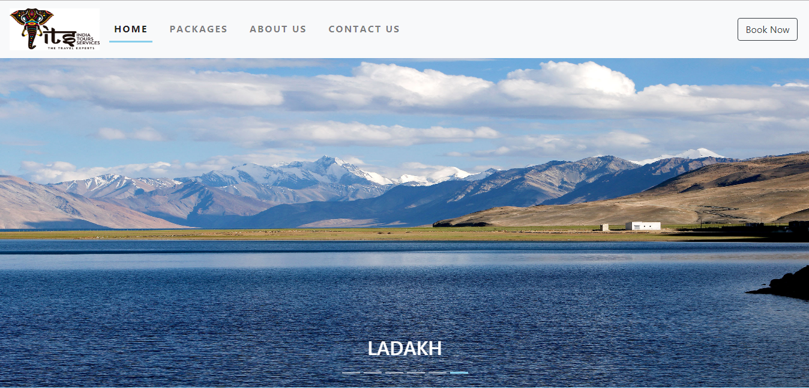

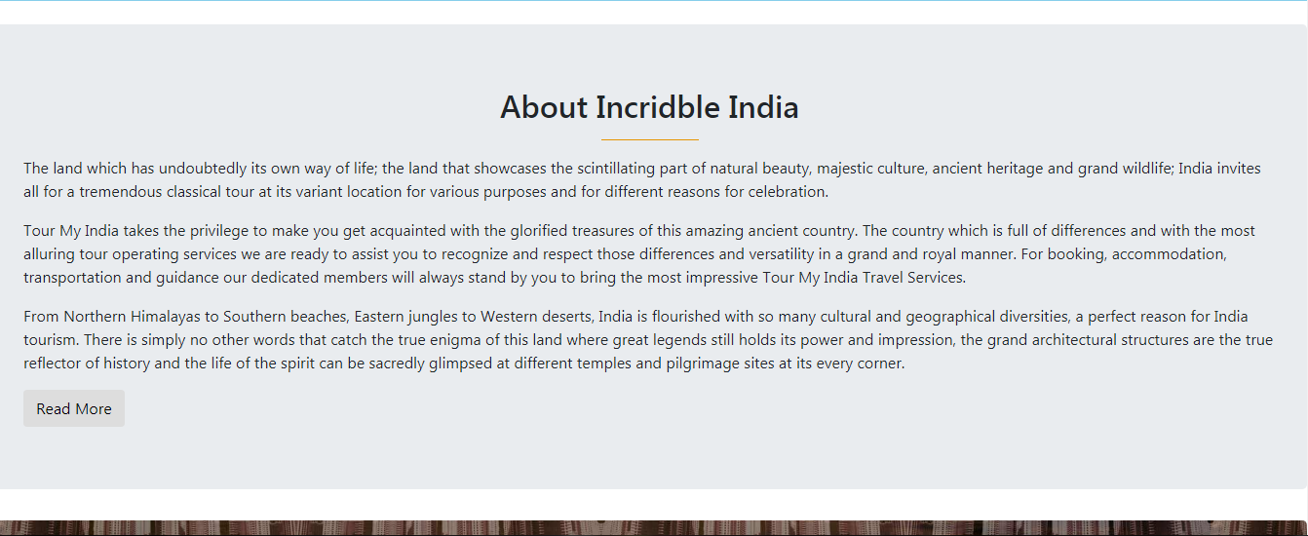

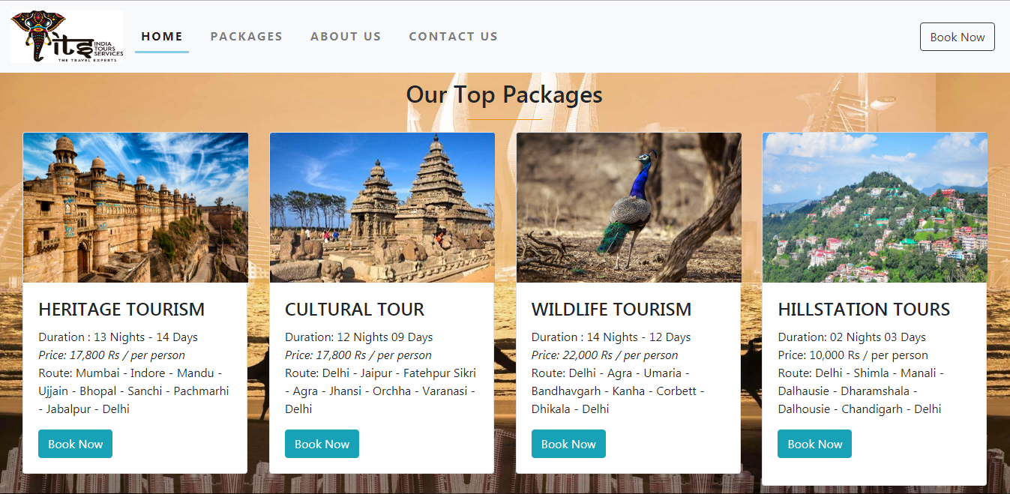

This is the main Index page of our website. Here you will get main content of our

website related travel and places in all india. You will find our top packages and

about Incridble India.

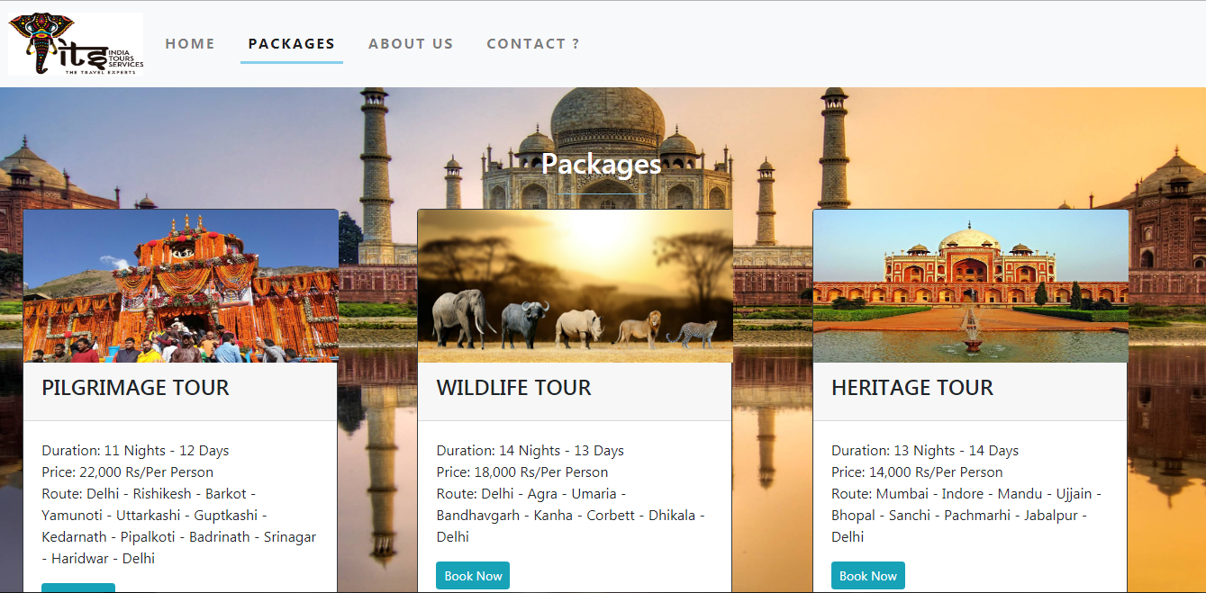

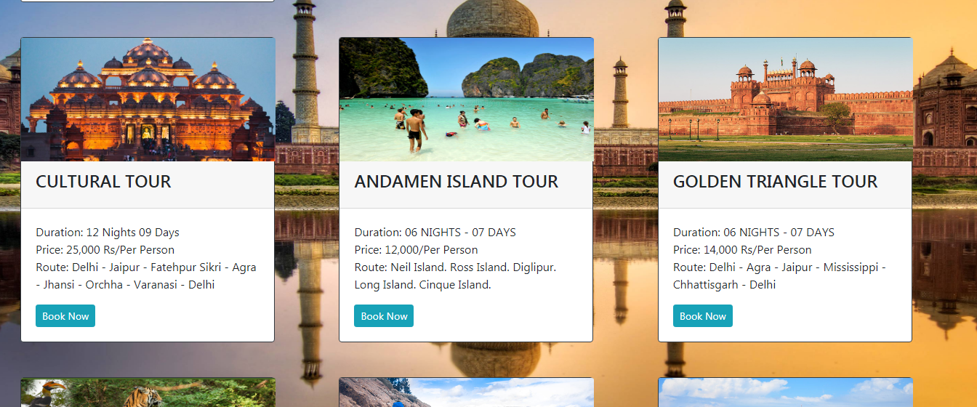

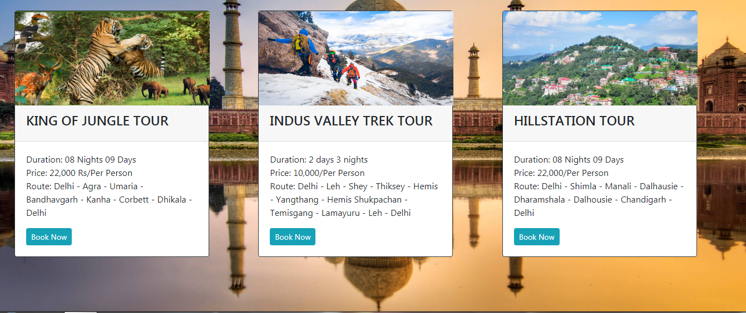

This is the “Packages“ Web page for the user to see all our packages of various tours

in various states of India. The tours consist of the details about starting point and

ending point,how many days and night and price of the tour package.

 This is the “About Us“ Web page for the user to see about our company achievements,records,awards and about travels or yatra.

**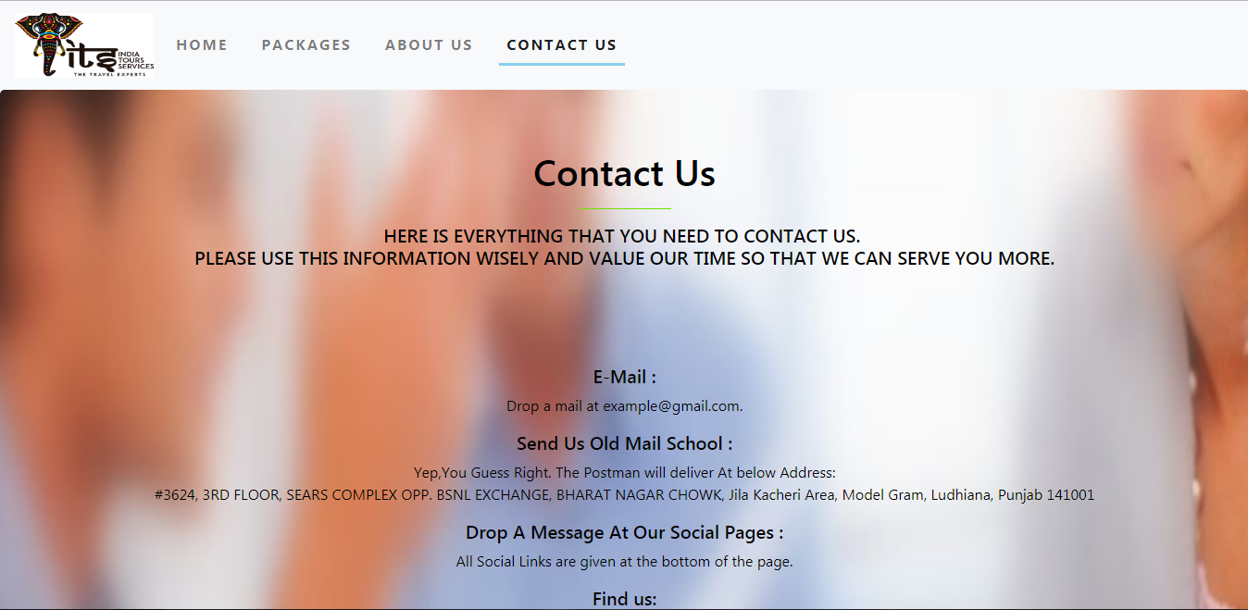**

**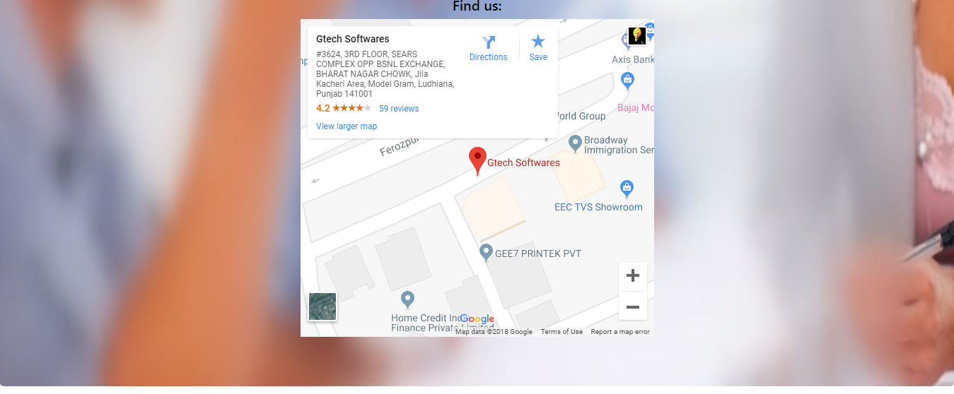**

This is the “Contact Us “ Web page for the user to contact us for any queries.

They will get all information here from contact number to addresses.

**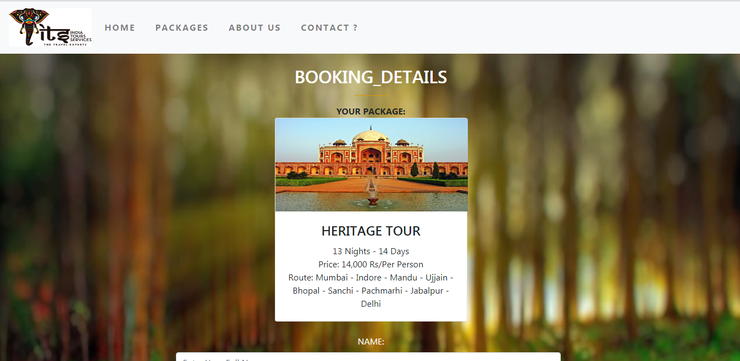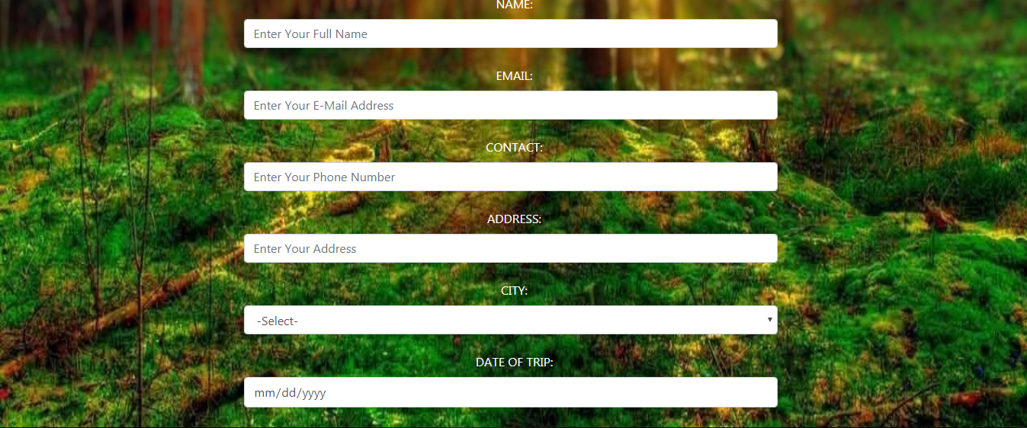**

**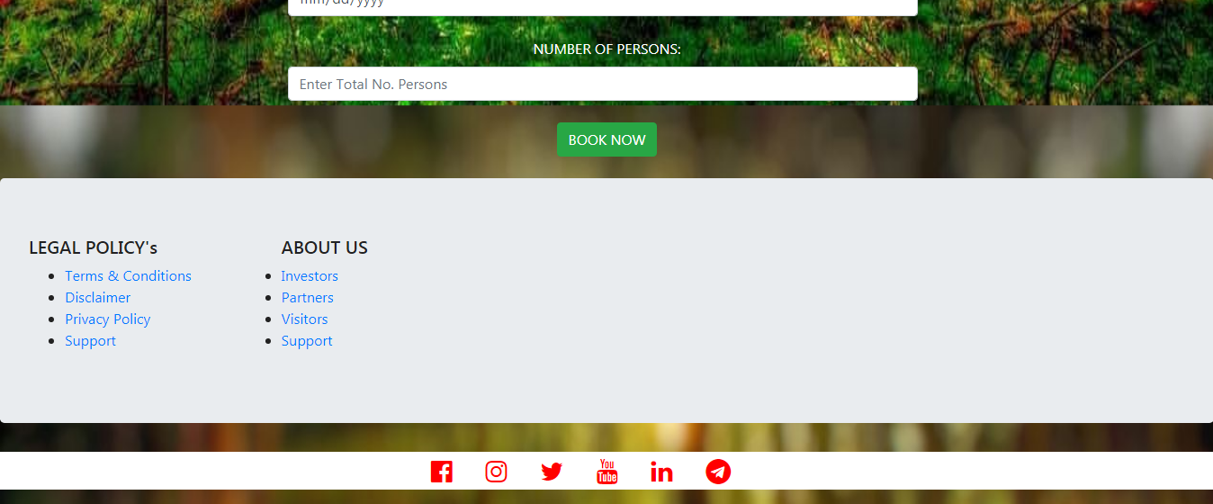**

This is the “Booking“ Web page for the user after selecting the package, the user will

Get on this page. This page is all about the details of the user for verfication purpose.

**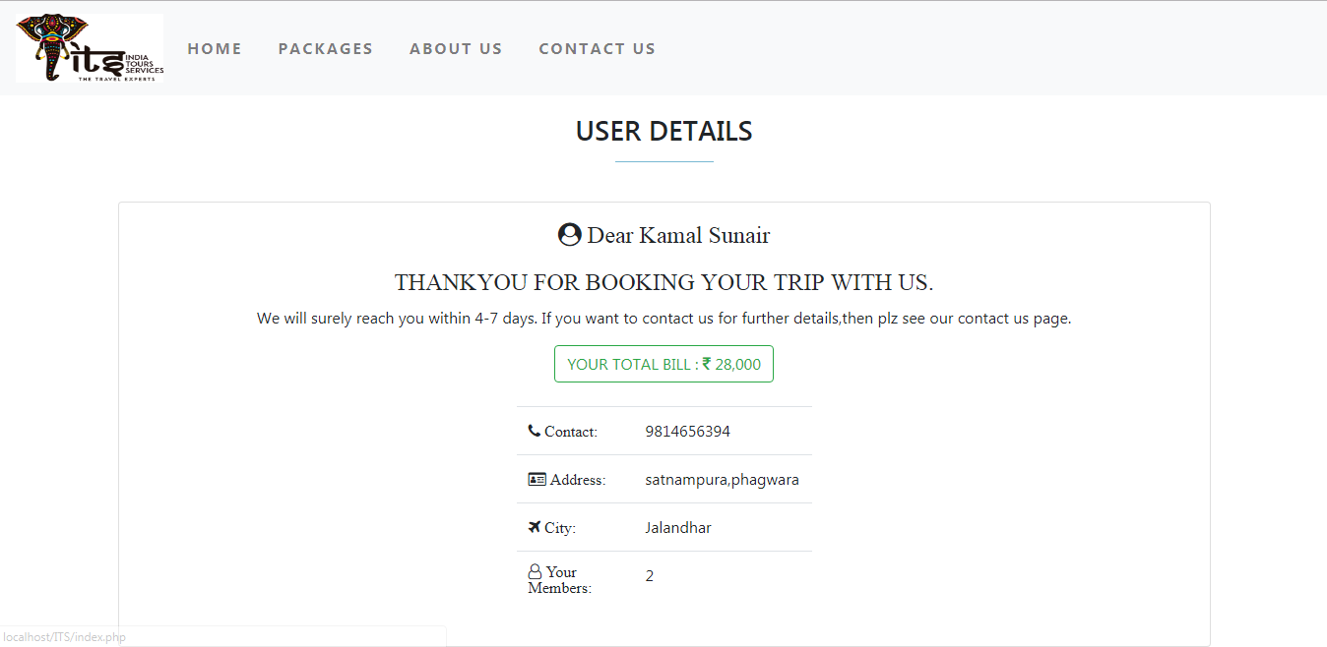**

This is the “Recipt page “ Web page for the user to contact us for any queries.

They will get all information here from contact number to addresses.

**Conclusion**

A developer of project tries his better to make a powerful and effective package. This project shows the working of software package of “**Indian Tours Services**”. This project works successfully and adding more control and making the program look more sophisticated can enhance its working functionality.

All steps of database designing have been followed properly. This has strengthened our understanding of

database design. We have made use of helpful features of PHP which helps the user to just select and click the desired record. We found PHP more interesting than any other language.

**BLIOGRAPHY**

<http://www.w3schools.com/>

<http://www.google.com/>

[http://www.kisspng.com/](http://www.tizag.com/)